Testing document.

Table of Contents

Junit 2

Login/register 2

Home activity 4

Journal page 5

Date Text 5

Trends page 7

Mindfulness 10

Animations 12

Improving modularity 13

No fix 14

# Junit

Junit tests used to check moodlog creation, validation, and simple logic tests. These simple tests ensure that the key features of the application work.

|  |  |  |
| --- | --- | --- |
| Test | Check | Outcome |
| Duplicate username | Check for username within a list | Passed |
| Empty variables | Check login input is not blank. | Passed |
| Moodlog created | Tests the class constructor and getters | Passed |
| Empty description | Make sure a blank description is replaced Providing user feedback. | Passed |
| Average mood | Calculates the average mood from a list of logs | Passed |
| Top activities | Calculates the most common activities from list | Passed |

# Login/register

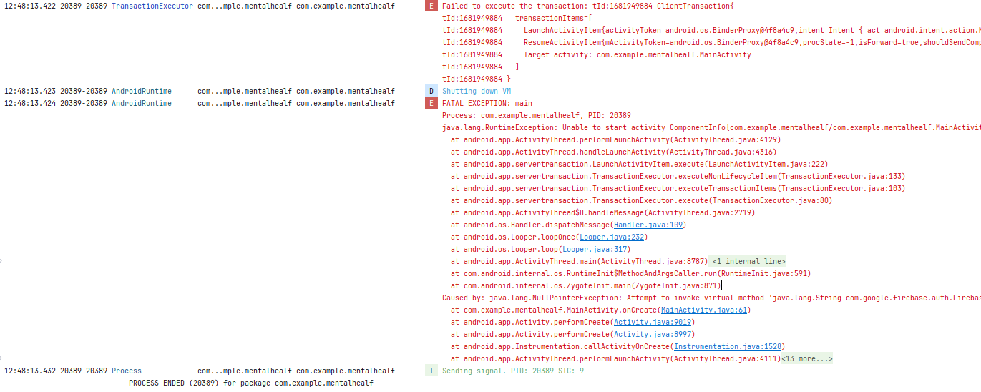

I started getting this error after rebuilding the application.

This line:

Indicating that I was attempting to call a user function. getUID () on a null object.

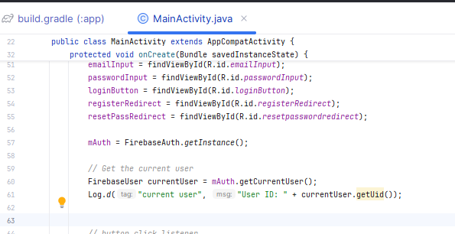

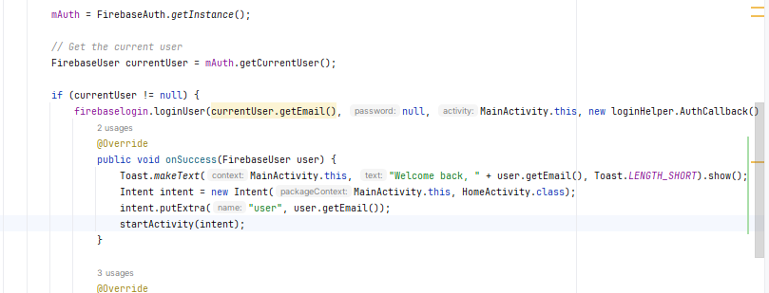Line 61 is the culprit, as I rebuilt the application, it reset, and no previous data is saved such as the currentUser. Implementing a simple check to see if the value is null should resolve this.

Checks if there is a previously logged in user, and logs in if there is, if not, nothing

# Home activity

The text background does not look good, it will have to replace this visual response with another thing.

# Journal page

The date is shown in the full timestamp layout, and it covers the edit text.

I will reformat the timestamp to view it in the “21:30” format.

I will transform the firebase date to a java date format which would allow me to reformat into HH:MM. ( <https://www.geeksforgeeks.org/date-and-time-formatting-in-android/> )

We will also show only one day at a time as currently all logs show.

## Date Text

This does not let you pick a date (edit text with input type date). I have found this which seems to be more appropriate: <https://developer.android.com/develop/ui/views/components/pickers>

Changed and used the calendar dialog inside the Journal Activity, trying to use the date selected to view logs from only that date, however, it only Works for the current day.

Correct Date passes through the function (When selected).

Wrong



Date stored is dd/MM/yyyy, where as the date passed is showing as d/m/yyyy. This is as java removes the zero when it converts to a string.

<https://stackoverflow.com/questions/275711/add-leading-zeroes-to-number-in-java>

The logs are now sorted out in their different days, essential to show a daily log. And updating when needed.

# Trends page

Look for an equivalent of matplotlib in PY for java.

|  |  |
| --- | --- |
| Criteria | Met? |
| Show trends | yes |
| Allow choose time periods | Yes |
| Show predicted | Sort of |

Tools; https://stackoverflow.com/questions/18992184/java-plotting-library-like-pythons-matplotlib

<https://github.com/sh0nk/matplotlib4j>

compile 'com. github.sh0nk:matplotlib4j:0.5.0'

requires python, java-based library would be superior.

<https://github.com/PhilJay/MPAndroidChart>.

https://weeklycoding.com/mpandroidchart-documentation/

The times are sorted over 24 hours, but as there are multiple days, the days are overlapped and that is why its foes back and forth.

I need to increase my daily life. Or sorting them in a MM: WW:DD: HH:MM type format would work.

Same first-time log (x=0).

Subtract it from each subsequent log which would allow for consistent increments, and it would not overlap. Annoying me. No need to go into seconds to calculate any of it. Just restart.

Too many problems trying to filter the getallmoodlogs query to show a range. Will make another function but using the greater than and less than queries.

Cleaned the chart up by removing some of the stylings, the data shown oscillates a lot which makes it hard to read. I will include a line which indicates the average (mean value) for the specific time.

Calculating if its increasing or decreasing or staying the same. Logistic regression.

No, it is linear regression.

https://stackoverflow.com/questions/8406305/is-there-a-java-library-for-better-linear-regression-e-g-iteratively-reweigh

<https://commons.apache.org/proper/commons-math/userguide/overview.html>

Plotting moving averages may make it easier to interpret the graph.

=====

Most frequent activities:

Only active when the time range is more than a day.

Currently I am trying on five of the activities which work when the current day is selected.

if (!timeRange.equals("Day")) {  
 List<Map.Entry<String, Integer>> topActivities = getTopActivities(moodLogsList, 5);  
 if (!topActivities.isEmpty()) {  
 trendInfoText += "\n\nMost common activities:";  
 for (int i = 0; i < topActivities.size(); i++) {  
 Map.Entry<String, Integer> entry = topActivities.get(i);  
 trendInfoText += "\n" + (i + 1) + ". " + entry.getKey() + " (" + entry.getValue() + " times)";  
 }  
 } else {  
 trendInfoText += "\n\nNo activities logged in this range.";  
 }  
}

When the selected date is not today’s date, it only shows three of the activities.

# Mindfulness

Current activities

1. ActivityHome.java
2. ActivityJournal.java
3. ActivityMain.java
4. ActivityMindfullness.java (Typo: Should be "Mindfulness")
5. ActivityResetPassword.java
6. ActivitySettings.java
7. ActivitySignup.java
8. ActivityTrends.java

Currently I have eight mindfulness, adding eight more activities may cause the app to lag and/or too much resource used. Will implement fragments. Enhances modularity, aligns with android best practices, and will reduce resource consumption.

* Exercise
* Metta
* Yoga
* Mantra
* Attention
* Guided me
* Box breathing
* Gratitude

Timer

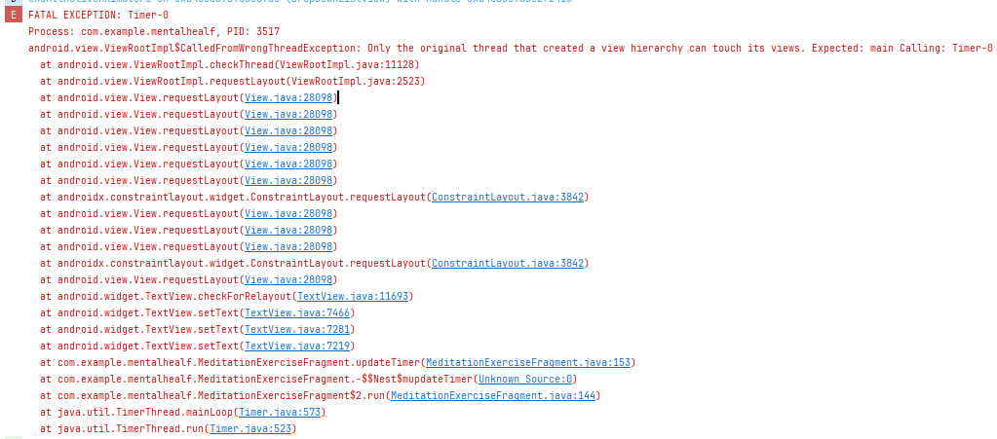

As the timer is ran in its own thread, and you can’t update the fragment thread from the timer, hence setting a context would resolve the issue.

Weird error

The duration is wrong when a countdown is selected, and the start time is also wrong.

Works fine when freestyle is selected, I will get txt value when the button is clicked and minus that from the total time to give me correct duration.

After going back, I get this error (Using android native back button)

This is because the activity is not removed from the pop stack and when it returns it attempts to continue the timer, but the fragment is not attached anymore, this causes the error. To fix this, I removed the fragment from the pop stack.

require Activity(). finish();  
added this to the function which navigates to the next page, this has fixed the error   
https://positivepsychology.com/loving-kindness-meditation/  
https://positive.b-cdn.net/wp-content/uploads/2021/04/Loving-Kindness-Meditation.pdf

Another timer issue, sometimes the clock foes from 5,3,2,1 instead of 4,3,2,1  
this is because the numbers do not align properly. Most probably due to a rounding error,   
  
 int seconds Remaining = (int)Math.round(millisUntilFinished / 1000.0));  
  
math. Round fixed it.

# Animations

https://developer.android.com/develop/ui/views/animations/prop-animation

# Improving modularity

All code was in the main class but was moved to separate functions outside separating the validations and the process of registering.

# Notifications

https://developer.android.com/develop/ui/views/notifications/build-notification#groovy

# No fix

Error however app runs fine. Could not find any solution.

https://issuetracker.google.com/issues/369219148?pli=1

online thread with many people with the same issue.